## 

## **Behavioral Triangle**

## **Structure your answers using 1 of these methods:**

These questions are designed to assess your soft skills and how you approach work in an international context.

1. **STAR method (Situation, Task, Action, Result).**
2. **X,Y,Z** Method (X: Accomplished what? Y: Measured by? Z: By doing what? )

* X: (What did you achieve?)
* Y: (How did you measure success?)
* Z: (What actions did you take?)

1. **P.A.R.A.D.E** (Problem, Action, Result, Analysis, Demonstration, and Evaluation)
2. **S.C.O.R.E** (Situation, Complication, Outcome Expectation, Remedial Action, End Result)
3. **L.A.I.R** (Listen, Analyze, Identify, Recommend)

Note: Scenarios must be realistic and not stories.. because they will ask followup questions. DO NOT READ THE ANSWERS, Record yourself and Practice as much as you can.

## **Real-World Questions for Global IT Roles.**

**General Skills:**

1. Tell me time you had to face a challenging customer.
2. Tell me time you had conflict with manager and how did you sort?
3. Tell me about a time you had to work effectively under pressure to meet a tight deadline. (Adaptability, Time Management)
4. Describe a situation where you disagreed with a colleague's technical approach. How did you handle it? (Communication, Teamwork)
5. Give an example of a time you had to learn a new technology quickly. How did you approach it? (Learning Agility, Problem-solving)
6. You're working with a team member from a different cultural background. How do you ensure clear communication and collaboration? (Cultural Competence, Communication)
7. Tell me about a time you had to explain a complex technical issue to someone with no technical background. (Communication, Client Service)
8. Describe a situation where you had to manage a conflict between two team members with different working styles. (Conflict Resolution, People Management)
9. How do you handle tight deadlines and multiple priorities? Can you give an example?(Organization, Time Management)
10. Give an example of a time you had to delegate tasks effectively. (Leadership, Delegation)
11. How do you stay motivated and keep your energy levels high when working on a long-term project? (Motivation, Self-Management)
12. Describe a situation where you had to adapt your communication style to suit your audience better. (Communication, Adaptability)

**Technical Skills & Problem-Solving:**

1. **Tell me about a time you failed. How did you handle the situation and what did you learn from it?(Self-Awareness, Learning from Failure)**
2. Describe a challenging technical problem you faced recently. How did you diagnose and solve it? (Problem-solving, Analytical Thinking)
3. You identify a potential security risk in a system you're working on. How do you escalate the issue and ensure it's addressed? (Initiative, Accountability)
4. Give an example of a time you had to troubleshoot a technical issue remotely. How did you approach it? (Communication, Problem-solving)
5. Tell me about a time you implemented a new technology that improved efficiency or productivity. (Technical Skills, Innovation)
6. Describe a situation where you had to document a complex technical process for others to understand. (Communication, Documentation Skills)
7. How do you approach debugging complex technical issues? (Problem-solving, Analytical Thinking)
8. Give an example of a time you identified an opportunity to improve an existing technical process. How did you implement the change? (Innovation, Initiative)
9. Describe a situation where you had to troubleshoot a technical issue with limited information. How did you approach it? (Problem-solving, Critical Thinking)
10. How do you stay up-to-date on the latest security vulnerabilities and best practices? (Continuous Learning, Security Awareness)
11. Tell me about a time you had to learn a new skill or framework for a project. (Learning Agility, Technical Skills)
12. Global Business Acumen (21-30):
13. How do you stay up-to-date with the latest trends and developments in your field, especially considering the global IT landscape? (Continuous Learning, Industry Awareness)
14. Imagine you're working on a project with a team in another country. How would you ensure effective collaboration despite time zone differences? (Time Management, Communication)
15. Have you ever had to adapt your technical approach or communication style to better suit an international client? (Cultural Competence, Adaptability)
16. How do you see your technical skills and experience contributing to a global company? (Global Business Acumen, Self-Awareness)
17. Describe a situation where you had to research and understand regulatory requirements specific to a different country. (Adaptability, Global Business Awareness)
18. (For Senior Roles) Tell me about a time you had to mentor or lead a team, especially one with diverse technical backgrounds. (Leadership, Teamwork)
19. Describe a situation where you had to manage a project with a limited budget. (Resource Management, Problem-solving)
20. How do you approach building relationships with colleagues and clients from different cultures? (Cultural Competence, Communication)

**Action Step:**

**CHATGPT Prompt:**

* **Name:** [Your Name]
* **My Current Role:** [Your Job Title]
* **Experience:** [Number of Years in IT]
* **Specialization/Track:** [Your IT Specialization]
* Preparing for my Behavioural interview for: ABC Netherlands

**Your Question:**

* **Describe your situation:** [Briefly explain the context or challenge you faced]
* **Describe what you did:** [Explain the actions you took in response to the situation]

OR

Question from the above list with your your Version.

**Choose One of the Framework that suits you best and Structure Your Details:**

1. **STAR** method (Situation, Task, Action, Result).
2. **X,Y,Z** Method (X: Accomplished what? Y: Measured by? Z: By doing what? )

Can you provide a detailed solution or real-world example using this framework?

**TOP FAANG Companies are a good starting Point:**

1. [Facebook/Meta](https://www.metacareers.com/swe-prep-onsite/)
2. [Amazon](https://www.amazon.jobs/content/en/how-we-hire/interviewing-at-amazon)
3. [Apple](https://www.apple.com/careers/ie/)
4. [Netflix](https://jobs.netflix.com/intern-program)

[link 2](https://4dayweek.io/interview-process/netflix)

1. [Google](https://www.google.com/about/careers/applications/how-we-hire/)

**Sample Answers:**

Q1. Tell Me about Yourself

Tell me about yourself – **Max 2-minute simple answer** - Use this as a base. Fill in your details. Practice 5 times with a timer. No need to memorize – just make it your story.

**Small Intro:**

Thanks for giving me the Opportunity to present myself. My name is [Name], I’m from Mumbai, and I have 7 years of experience in data analytics, big data, and cloud technologies like AWS. I really enjoy working with data and building smart, scalable systems that help teams work better.

**Current Role:**

Right now, I work at Cisco. I build and manage data pipelines using tools like Airflow, Python, PySpark, and SQL. I design ETL workflows and use AWS to improve performance and reduce costs. One of my recent projects helped cut processing time by 40%, which made data available faster for business teams.

**Previous Experience:**

Before this, I worked at companies like Air Products, Accenture, and Amazon. I contributed to cloud-based data solutions, improved real-time reporting, and closely collaborated with cross-functional teams. Across these roles, I focused on building scalable systems, improving data quality, and driving better decision-making through data.

**Certifications and Learning:**

I’m certified in SQL and currently learning Google Cloud and Generative AI. I enjoy learning new technologies and staying updated to keep delivering value in a fast-changing tech space.

**Why this country, company, and role:**

I’m excited to move to [Country] to be part of diverse, international teams and work on global cloud data projects. I found this role very exciting, as it closely matches my skill set and gives me a chance to grow while contributing meaningfully.

**Closing:**

I’m a self-driven person who enjoys solving problems and building systems that make real impact. I work well with diverse teams and believe in open and respectful communication. I value collaboration over hierarchy and always aim to create a positive working environment. I'm excited about the opportunity to bring my experience, energy, and curiosity to your team and contribute from day one.

Thank you.

________________  
Example Template:  
________________

**Introduction:**I am [Your Name], a Network Engineer with [X years] of experience specializing in [specific area, e.g., Network Engineering, Cloud Infrastructure, or Software Development]. I have hands-on experience with [specific tools or technologies relevant to the job, e.g., Cisco devices, AWS, Python], which aligns with the technical requirements of this role.

**Core Skills and Achievements:**I’ve successfully [specific accomplishments, e.g., optimized network performance by 30%, automated deployment processes reducing time by 40%, or implemented security protocols that ensured compliance]. My work has directly contributed to improving operational efficiency and supporting business goals.

**Why EU and This Role:**I am seeking opportunities in the EU to bring my expertise to global projects, particularly those involving [specific focus, e.g., large-scale cloud migrations, SD-WAN deployments, or full-stack development]. I have researched your organization and believe my skills in [specific matching skills] can add significant value to your team.

**Closing Statement:**I’m ready to deliver results from day one, and I’m eager to collaborate on projects that drive innovation and growth. My priority is to contribute meaningfully to your team while continuing to refine my technical skills in a challenging environment.

### **Sample ANSWER using the STAR and XYZ Method.**

### **STAR Method:**

#### **Situation:**

In my previous role as a Network Engineer, I was working on a multinational project where a client’s European data center faced frequent network outages. These disruptions were causing downtime for critical applications.

#### **Task:**

I was assigned to redesign the network to improve reliability and ensure 99.9% uptime, which was essential for their operations in multiple EU locations.

#### **Action:**

* Conducted a full **network audit** to identify root causes of the outages.
* Implemented **dual WAN links** with automatic failover to prevent single points of failure.
* Migrated to a **Cisco Nexus-based infrastructure** for better scalability and performance.
* Configured **Quality of Service (QoS)** to prioritize critical traffic and ensure stability during peak hours.
* Documented the entire process and collaborated with EU-based teams to ensure seamless integration.

#### **Result:**

* Achieved **zero outages** in the following 12 months.
* Improved application performance by 30%, as measured by end-user feedback and system logs.
* Received recognition from the client for successfully meeting SLA requirements across multiple EU locations.

### 

### **Using the XYZ Method:**

* **X (Accomplished what?):** Redesigned a European client’s network to ensure 99.9% uptime and improve application performance.
* **Y (Measured by?):** Achieved zero outages in 12 months and improved application performance by 30%.
* **Z (By doing what?):** Conducted a network audit, implemented dual WAN links with failover, upgraded to Cisco Nexus infrastructure, and configured QoS to prioritize traffic.

**Complete Answer Using XYZ:** "I redesigned a European client’s network, ensuring 99.9% uptime and improving application performance by 30%, by auditing the network, implementing dual WAN links with failover, upgrading to Cisco Nexus, and configuring QoS for critical traffic."

**Few Straight forward Examples**

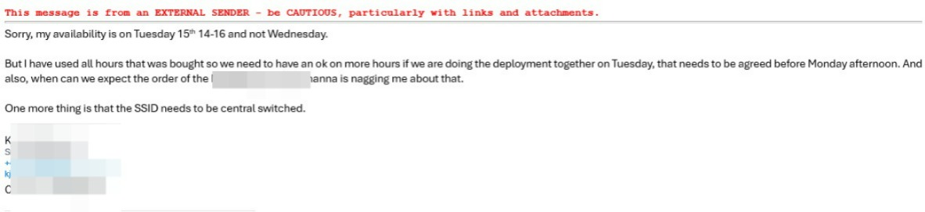

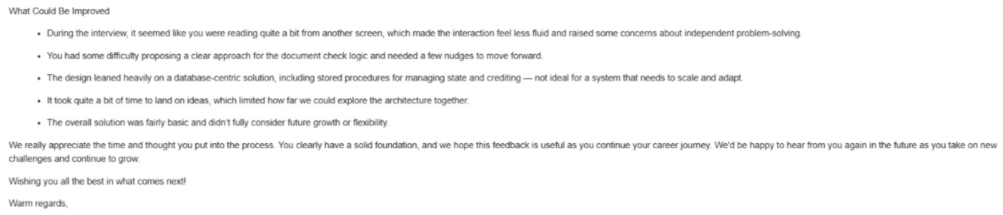

Resources: FREE (Do NOT Buy )

* **PracticeAptitudeTests.com:**
* **https://www.practiceaptitudetests.com/aptitude-test-sample-questions-and-answers/**
* **Aptitude-Test.com:**
* **https://aptitude-test.com/**
* **12minprep.com:**
* **https://www.12minprep.com/knowledge-hub/free-criteria-cognitive-aptitude-test-practice/**
* **InterviewBit:**
* **https://www.interviewbit.com/practice/**
* **iScalePro:**
* **https://www.iscalepro.com/post/coding-aptitude-questions-with-answers-2024/**
* **https://www.graduatesfirst.com/employers**